How to setup the Arduino IDE for the audio light-sensor!

(A helpguide to support visually impaired people)

Ilham Simon, Office of Astronomy for Development

Install the Arduino IDE 1.8.5

Download Arduino IDE from Arduino.cc (1.8.5) from Arduino.cc
Step 1
We reproduced this steps succesfully using Google.
Instructions on downloading arduino IDE 1.8.5
- Search for the arduino IDE 1.8.5 by typing arduino 1.8.5 in the address bar and press enter to search.
- Once the results of the search are displayed, (if using a screen reader like NVDA call the elements list pressing NVDA+f7 or in Voice Over call the element list using VO+U) this will show you a list of things you can click on, at the very top of this list it should say arduino software. Select that one.
- Once you have clicked on this a new page will open, and it should say “Access the Online IDE”, call the element list again and type your operative system on the element list search. For example I type Mac and I select the first item showing on the element list. If you are using Windows, after you type any of the three items displayed on the element may serve you depending on your preferences. I usually select the first one but it is your choice.
- On the next page call up the element list again ( VO U or NVDA f7) on a Mac with the arrow key find the form control and select either just download download or contribute and dowload. The download will begin once you click on the selection of your choice.
- When it is finished downloading go to the download folder you will find the package there. (If you have problems downloading this IDE you may have to restart and update your computer or you can use another computer if you like)

Install the ESP8266 Board Package

Step 2
If you have any problems at this point you will find hints at the bottom
- Now click on the file menu item at the top of the window and find the sub-menu which is called preferences, now another menu named preferences will pop up
- Scroll down and find an item called ”Additional Boards Manager URLs” on its right it has an editable area go to it “http://arduino.esp8266.com/stable/package_esp8266com_index.json”
- Now click on ok at the bottom of the page

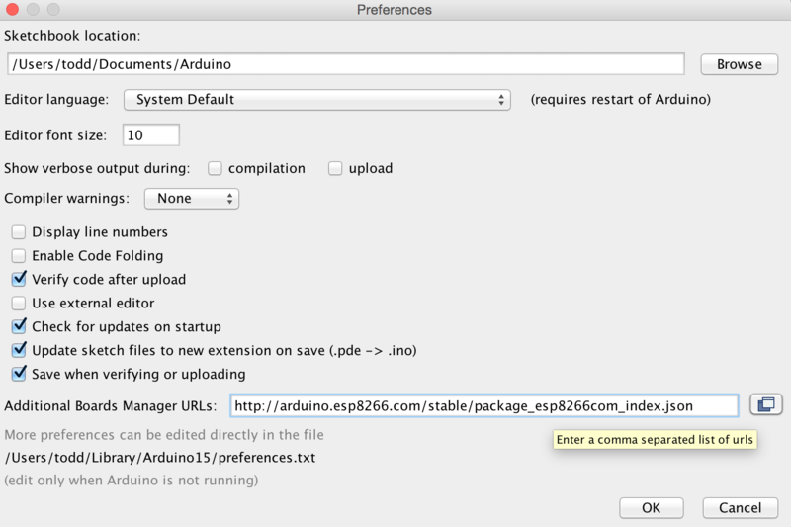
Figure 1. Image of settings preferences environment.
Step 3
Use the Board manager to install the ESP8266 package.
- in order for you to get to the boards manager you will have to click on the tools item on the menu bar.
- once you’ve done that you can find the drop down menu named “Board :Arduino/Genuino Uno”, scroll down to it and once there with the right arrow key once. A submenu bar will show with bunch of boards you can choose from but you will be using the up arrow to go to the top of the list and find Boards Manager
- when you click on it, it will open a window named Boards Manager, find the only editable area, in that area please write esp8266 and immediately the first item showing below will be esp8266 by ESP8266 Community. (Note In Mac with VO it was difficult to select the version and install options perhaps you will need help in this step).

Once you select install when its finished it will be marked INSTALLED and you will restart the IDE or it will restart for you (you can restart it by going out of the IDE 1.8.5 and going back into it)
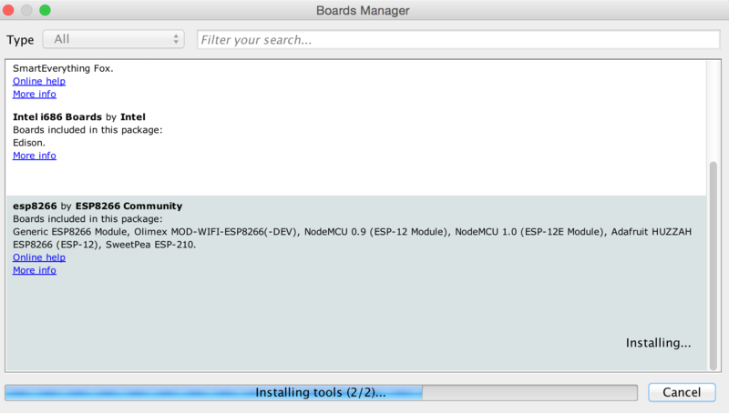
Image 2: board manager image.
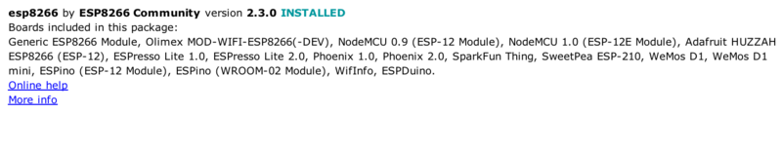

Setup ESP8266 Support
Step 4
It’s time for you to complete everything in the tool menu item section
- Now go back into the tools menu item (if it closed) and go to the boards dropdown box and using the arrow key select Adafruit HUZZAH ESP8266 which is under the heading ESP8266 Module which is at the bottom
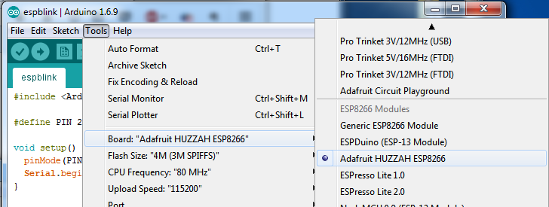

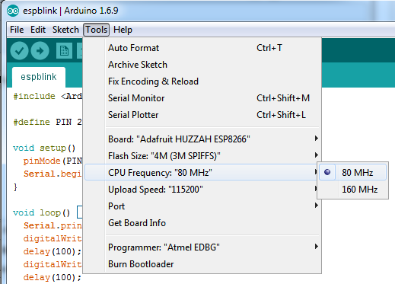
- Now go to the CPU submenu items located inside the tool menu item. Select the CPU frequency make it 80MHz if it is 160MHz (this is also under the menu item tools)

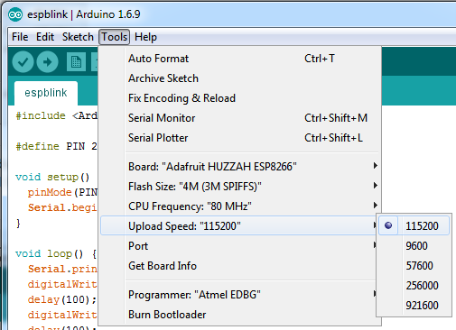
Image 3 image for Upload Speed setting
- Inside the many item Tools find Upload Speed, select 115200
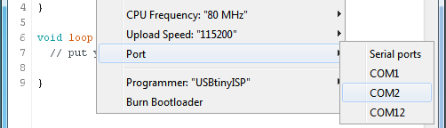
Image 4 image setting the com port

- Now you can change the port which is also under tools (before you can change the port you will have to have the arduino connected to the computer The matching COM port for your FTDI or USB-Serial cable
(when I had to go to the port it was written in grey and I could not understand why so I had received help from my father and he said it needed to be plugged into the computer and the arduino board must be plugged in as well before I will be able to go into that dropbox )

Step 5
Now you need to download the libraries!
- Now you can upload the code but you need all the libraries that is needed for that board, now you are going to go Google and find a website but in order for you to get to this website you are going to have to go into Google Chrome/Mozilla Firefox/etc (whichever web you would like to use)and once you’ve gone into your preferred web you can type the address in the address bar at the top ( the address names are https://github.com/adafruit/Adafruit_TSL2561 )
- Once you have done that the computer will load a new page called Github.com once you are in this website you can look at the right bottom corner of this page and find you will see a green box named “Clone or download” click on it .
- Once you have clicked on it, it will open a new box that is named Clone with HTTPS, in the right bottom corner of that box it will say Download ZIP, click on it.
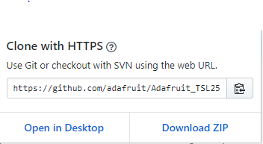
- Once you’ve done that it will start downloading and it will show another box at the bottom left corner of the screen, while it is downloading you can start downloading the other zip file as well
- In order for you to download this zip file without disturbing the other download you will have to go to the top of the screen and find a plus sign+ or a block with a plus sign in it next to tab called GitHub, click on that little block or plus sign
- Now it will open a new tab and a new blank page with Google in the middle, go to the address bar at the top of this page and type this address https://github.com/adafruit/Adafruit_Sensor and press enter on the key board
- When you pressed enter it will open a similar page, once this page is open you will have to do the same thing you did on the previous website but I will go through it again for you, click on the green with the name of Clone or download ZIP button at the right bottom corner, click on it
- Once you clicked on it will open another box with the name of Clone with HTTPS, in that it will say download ZIP on the bottom right corner, click on it. Now it will start to download and open another block at the bottom left corner of the screen
- It should be finished downloading after a few seconds, now click on the block that opened at the bottom
- When you click on it, it will open a file explore and on the side of the file explore it will show a list of options, now in that list find Downloads once you’ve found it you can click on it
- When you click on it, it will open a file next to it and in that file you will have to find a list with different types of files next to it, in that list find a compressed file called Adafruit_TSL2561-master(1) click on that file, once you clicked on that file it will open that file.
- Once it has opened this file you will have to open a folder which is name Adafruit_TSL2561-master, click on that folder, once you’ve clicked on it, the folder will show you a list starting with a folder with the name of .github now that you’ve found the first compressed file you will have to find another one with the name of Adafruit_Sensor-master
- You can get to this file by going back to downloads and finding this name Adafruit_Sensor-master, when you find it click on it, it will open the file then there should be a folder there named Adafruit_Sensor-master, click on that folder. Now you will see that this folder a small list starting with Adafruit_Sensor.h
- Now that you know how to get to those files you can to go back into arduino IDE 1.8.5 and then go to the top of the IDE and click on the sketch menu item, then go to “Include library” dropdown and click on Add.ZIP library at the top
- Once you have done that it will a file that looks like this: 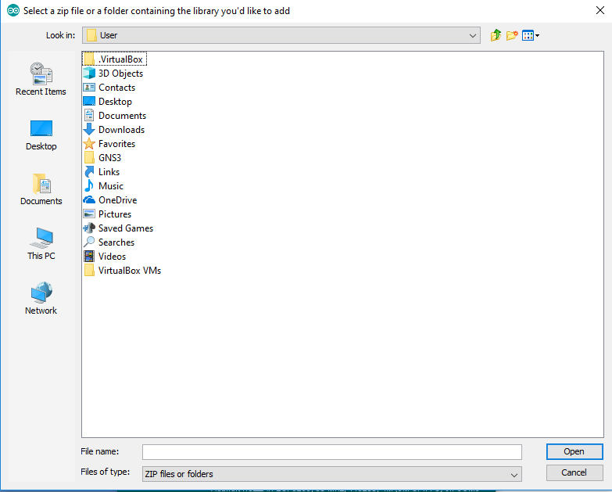 now that you know how it looks try to find the downloads file, once you’ve found it you can click on it, after you clicked on it, it will show you a list in this list find Adafruit_Sensor-master click on it, once you have done that it will go out of the page and it would be downloaded onto the arduino IDE, now you have to go back to the sketch menu item and find downloads for the last time and click on it, now find Adafruit_TSL2561-master,click on that file, now it will close the page once more and the Adafruit will be downloaded onto the arduino IDE
- You will also need the code for arduino audio light-Sensor, the code will be copied to you clipboard by clicking here

Step 6
Well done you have finally reached the final step!
- Now you can finally upload the code, in order for you to upload this you will have to go to the top of the IDE and you will see and box with tick in it, click on that box this will verify your code
- When it has finished you can upload the code by clicking on the box with the arrow that is pointing to the right
- Once it has finished uploading the arduino should make a sound if your in a room with light in it

